**Computer Vision - 217**

**Homework 3**

**Chen Naveh - 301841664**

**Elad Wasserstein - 204499149**

**Answers for questions:**

**Part A: Computing OF using Lucas-Kanade**

Question 5:

I ran the function OF in several scenarios:

1. Several pairs from the video Slide.avi
2. W - Changing the window size of the region
3. K - The distance between frames
4. Sigma – the sigma of the gaussian

When using bigger window size each pixel has more influence on its neighbors, i.e. the algorithm can mark a pixel moving in an opposite direction or has a smaller magnitude because of its neighbors. Moreover, when using larger window, the Taylor series used in the construction of the optical flow formulas will be less accurate and therefore the approximation will be damaged.

When increasing K (the distance between frames) we sample the video in a lower frequency which can lead to loosing fast motions. When using all frames we get better accuracy but also more noise as we detect minor changes in the background. Also using all frames will have effect on the performance of the algorithm.

Question 8:

1. We chose to scale the image from 0.3 to 0.8. Here a sample example of 2 scales:

**1st picture with scale of 0.8:**

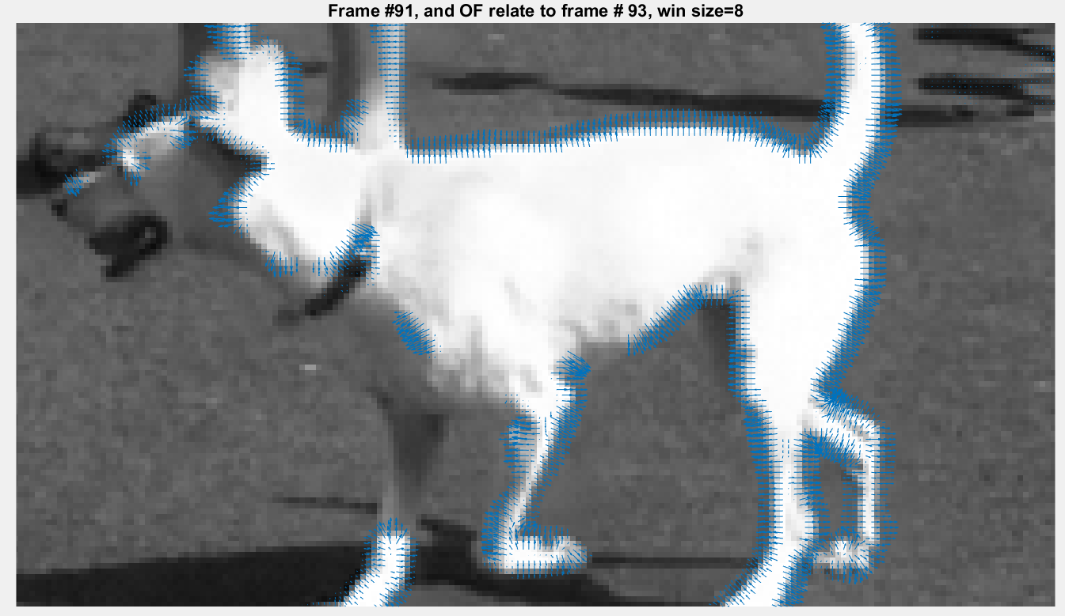

**2nd picture with scale of 0.3:**

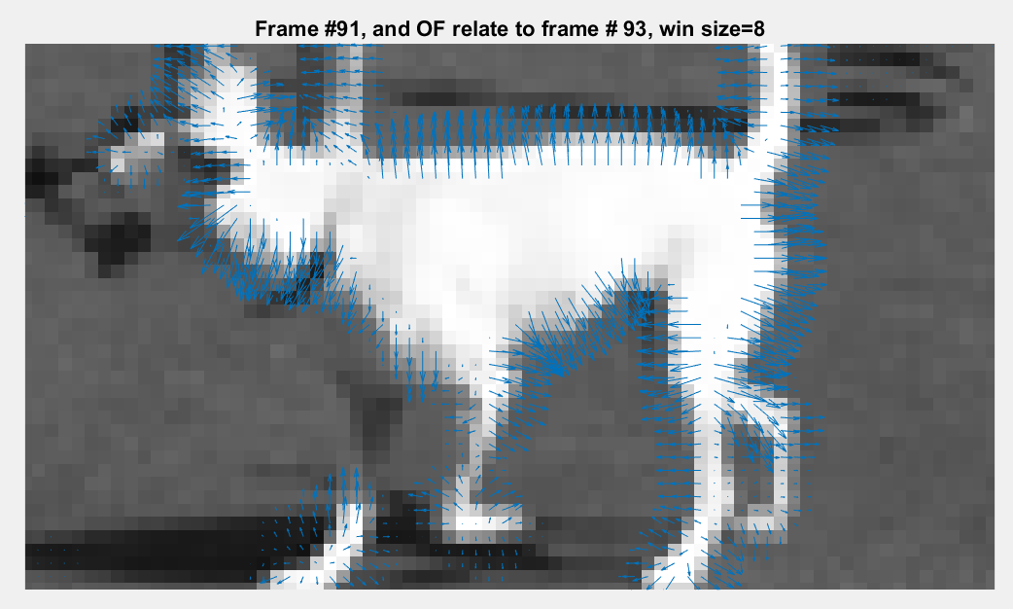

1. The scale parameter affects the pixel resolution of the image. In small scales the image pixels appear bigger and the image is more blurred, this allow us to detect changes in large items in the image. As the scale get closer to 1 we get the original image which contain more pixels and more fine details. This allow us to detect minor changes and is more susceptible to noise. The right order to use will be small scale first and large scale at the end. This allows us to get major movements first and then to refine the changes be using higher resolution.

**Part B:**

* No question in this part

**Part C:**

Question 14:

* The OF has an advantage to recognize better edges in contrast to the median change detector where it has better performance on the objects itself.
* The median has better results to detect when there are fast changes because the median filter looks for the majority intense of each pixel. For instance, the median detector recognized great the fast-moving dog in the movie.
* A region OF works better is at the top of the slide region. Most of the video the children are sitting on top of the slide, when they move the algorithm recognize the slide behind them (as shown in the following figure). We obviously would think of the slide as the background and the children as foreground. This is an example for the median detector disadvantage as it estimates the background as the pixels median values (in our case the children) and the foreground as changes which appear for a short part of the video (the slide). 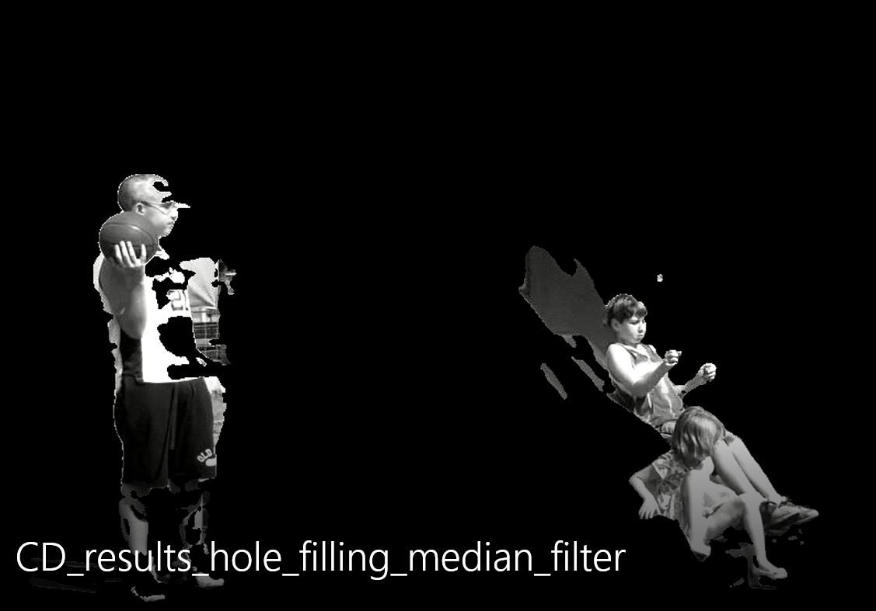

**Part D:**

Question 16:

The assumption we make when using magnitude thresholding is that the motion around each pixel is in the same direction (for the Taylor series) and intensity of the pixels should be consistent (we assume the objects/pixels do not change this also true for the illumination in the image).

Question 17:

No, it does not necessarily imply that they are projections of two 3D points that move at the same speed and direction.

For instance assume two objects in the 3D world, one which is further away from the camera and moves fast and the other which is closer and moves slower. both can be detected with the same optical flow.

assume two objects one which has vector component away from the camera (away from center of projection) and the other which doesn't. Both can be detected with the same optical flow (same vector direction in this case) even though they move directionally different in the 3D world.

Question 18:

In order to determine if a scene is planar we can apply the OF algorithm to the video. If orientation of the optical flow is equal for most of the scene then we can assume the scene is planar. The intuition is that in a video of a planar surface while the camera is moving, we expect most of the image to move in the opposite direction of the camera. So if the camera is moving to the left, we expect to see the patterns in the video moving to the right.

Question 19:

1. The expected orientation of the optical flow will be similar in all pixels and in the X axis. This is due to the fact that the scene is static, therefore all movements are the consequences of the moving camera. In this case the camera moves in the X axis and so all the scene should be moving in the X direction. No movement in the Y direction is expected.
2. In order to recognize if the object is far or close we can use the magnitude of the optical flow. While the large magnitude indicate that the object is close and small magnitude indicate the object is far from the camera.